Quick User Instructions for FDMS 2.0

A Description of the New Unattended Measurement Features of the Fork Detector Measurement System.

Joe F. Longo
N-1, Los Alamos National Laboratory
March 12th, 2005

I. Introduction 2
II. FDMS and Integrated Review 2
III. FDMS Standalone 3
IV. Radiation Review Data Preparation 3
V. Importing Data into Radiation Review 5
VI. Finding events in Radiation Review 11
VII. Preparing Radiation Review Events for Export to FDMS 21
VIII. Exporting Radiation Review Measurement Events to FDMS 29
IX. FDMS Analysis; Importing Events from Radiation Review 37
X. FDMS Import Measurement Dialog Details 41
XI. Background measurements 43
XII. Importing New Measurement Events 45
XIII. Reviewing the Import Analysis Results 52
XIV. Importing Existing Measurement Events 56
XV. Moving Data from Excel to FDMS 60
XVI. Reviewing the results 65
XVII. Preparing a Facility using the Facility Manager 68
XVIII. Detector or Station Definition 70
XIX. Naming: Long, Short, Numeric ID 71
XX. Channels 72
XXI. Copyright Notice and Disclaimer 73

Introduction

Version 2 of FDMS now offers unattended measurement data analysis. The current FDMS is used in attended mode to collect radiation data. To improve the usefulness of FDMS, the IAEA proposed it be enhanced and added to Integrated Review Software Suite, to enable use of data collected by unattended monitoring systems.

FDMS has now been improved to work with Radiation Review, importing events detected by Radiation Review in unattended data. These events are exported by Radiation Review for use by FDMS.

FDMS imports the events in a three stage process, taking Background events first, analyzing new events second, and finally analyzing measurement that match existing measurement in FDMS.

Each step of the import process in FDMS requires some event details to be added for each imported event to complete the analysis of the data. A tabular dialog style is used to display the event data and to allow editing and modifications of the data during import processing.

No FDMS 1.02 features were changed; FDMS data from existing FDMS 1.02 installations are fully compatible with FDMS 2.00.

FDMS and Integrated Review

FDMS 2.0 can be installed singly, or with other IRS tools.

The preferred combination is to install FDMS with Radiation Review. The installation package provided on the UNARM Baseline 1 Rev. 2 ESP 8 CD will install both Radiation Review and FDMS together. Position Review, INCC and Digital Video Review are also included as optional applications.

Before installing FDMS, please refer to Integrated Review Software Installation Manual – S. Klosterbuer, H. Nordquist, LA-UR-04-8626, February 25, 2005. This document is found on the installation CD under the Review Software link. Minimal system requirements are detailed in the document. Please note that any existing UNARM Baseline 1 installation should be backed up and removed prior to installing UNARM Baseline 1 Rev. 2 ESP 8. Your existing FDMS installation may be retained.

Installation of FDMS using the UNARM Baseline 1 Rev. 2 ESP 8 CD starts by inserting the CD in your computer. A page should appear momentarily in a web browser with the title “LANL UNARM Baseline 1 Rev. 2 ESP 8 with FDMS Installation CD”.

Select the “Please click here to install UNARM Baseline 1 Rev. 2 ESP 8 with FDMS” link on the first page that appears after CD insertion. If no page appears when you insert the CD, navigate to the CD using the Windows Explorer, find the file setup.htm, and open that file by double-clicking on it. The page should appear and you may proceed.

FDMS Standalone

A standalone installation for FDMS is available on the UNARM Baseline 1 Rev. 2 ESP 8 CD. As with ESP 8, the basic system requirement is a computer running the Windows 2000 or Windows XP operating system. Insert the CD. From the main page of the installation, select the Fork Detector Measurement System link on the left side of the page to view the FDMS description page. A link is provided on the FDMS description page for the standalone installation. Use of unattended measurement data is not available in the standalone installation. The FDMS software is identical (version 2.0) for both the UNARM Baseline and standalone installations, but the standalone installation is not configured to work with the IRS tools. The standalone and UNARM Baseline FDMS installation can co-exist on the same computer,

Radiation Review Data Preparation

Having successfully installed FDMS and Radiation Review, both tools are available from the “Start” menu under “Integrated Review Software”. Documentation for all installed IRS applications is found under the “IRS documentation” link on the same menu. See Figure 1 below.

Complete detailed guidance on using Radiation Review is found in Radiation Review User Manual – S. Klosterbuer, December 1, 2004, LA-UR-99-1965 (Rev. 3). This document is installed with Radiation Review by UNARM Baseline 1 Rev. 2 ESP 8.

Radiation Review (RAD) is used to prepare unattended measurement data for use in FDMS
- The raw unattended measurement data is imported into RAD.
- The data is reviewed graphically and numerically.
- Events of interest are then determined using RAD event detection features, such as ‘Find Channel Events’.
- Identified events are edited with identifying information,
- Background events are added using the ‘Create Event’ feature of RAD.
- Finally, the identified events of interest are exported for analysis by FDMS.

Each of these steps is covered in detail below.
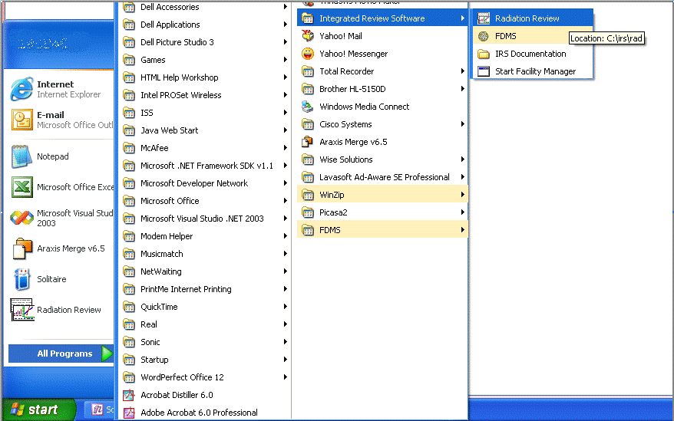
Figure 1 Starting Radiation Review from the Windows Start Menu

Importing Data into Radiation Review
Raw measurement data is collected by unattended measurement acquisition software using GRAND and miniGRAND instruments. This raw data is initially available as .BID files. For more information on the data collection process, see Multi-Instrument Collect User’s Manual - D. Pelowitz, P. Moore, T. Wenz, LA-UR-02-2371 (Rev), November 22, 2004. This document is found on the ESP 8 CD. Follow the “Collection Software” link on the left-hand side of the main page.

To import .BID data files into RAD, select the “Import” menu item and then “Import All …”. See Figure 2.

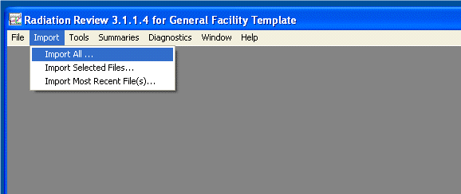
Figure 2 The Radiation Review “Import All …” Menu Item

A dialog appears (see Figure 3). Use this dialog to browse to the location of the BID files. Sample files are supplied with the ESP8 FDMS installation. They are found in the facility data folder for FDMS. For the rest of this document, these sample files are the source of data. Assume also for the purposes of illustration that the facility is named ‘general’ and the data and configuration folders and files for ‘general’ is installed at c:\general. The ESP 8 installation created this set of folders and files as part of the installation process.

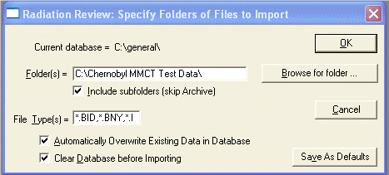
Figure 3 Import Folder Specification

Select the ‘Browse for folder …” button, and navigate to the supplied sample files, at “c:\general\data\fdms\BID Sample Data”. See Figure 4 and Figure 5.
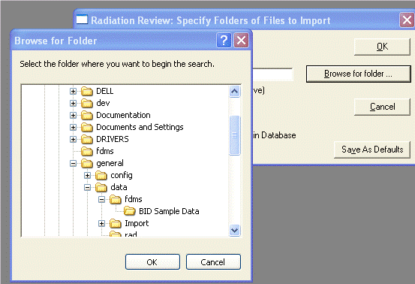
Figure 4 Browsing to the BID Sample Data Folder

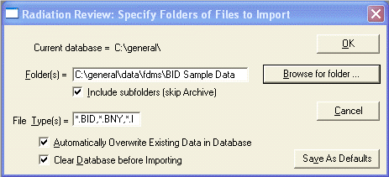
Figure 5 Import Parameters are Ready

If you have chosen to clear the database prior to the import operation, acknowledge the removal of preexisting data in the RAD database. See Figure 6.

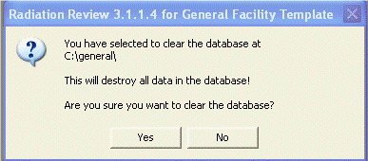
Figure 6 Affirming Database Clearing

The data import starts. RAD displays a progress bar and a textual display indicating the data importation progress. See Figure 7.

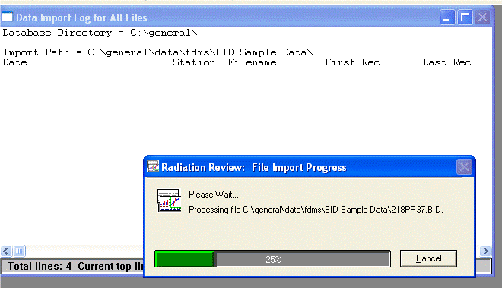
Figure 7 Radiation Review Data Import Progress

The results of the import operation are shown in Figure 8 below. In our example, two BID files were found with data from a MiniGRAND. Next, measurement events are determined from the imported data.

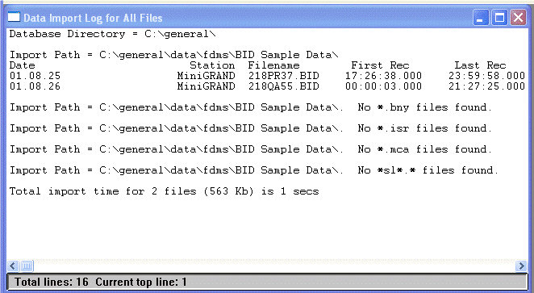
Figure 8 Radiation Review Data Import Log

Finding events in Radiation Review

A review of the imported data is first made by using the RAD graph. Events corresponding to radiation peaks are quickly identified and characterized. Reviewing the data in this manner will provide an indication of the quality, number of events of interest, and strength of the measurements relative to the measured background radiation. From this review a minimal threshold for event detection may be determined. That value will be used in the next step.

Figure 9 shows how the RAD graph tool is invoked.

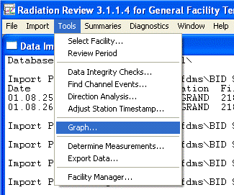
Figure 9 Radiation Review “Tools” “Graph…” Menu Item

Figure 10 below shows a time span of the data imported into RAD. Notice the easily discernable peaks in Neutron channels A and B, and Gamma channel 1. Also notice that Neutron channel C has no data and Gamma 2 is not useful.

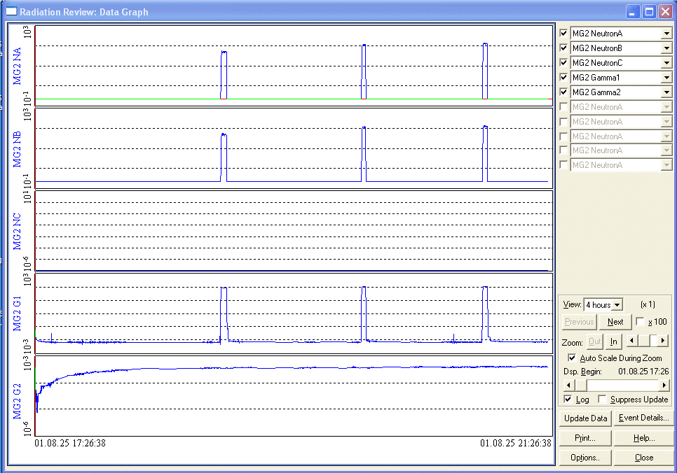
Figure 10 Graph View of Imported Data

Select a peak (See Figure 11) and determine a good value relative to the background for threshold detection. In this case, Neutron Channel A provides good data, and a review of the peaks shows that a value of about 20 up to 75 will give a strong indication of a radiation detection event. 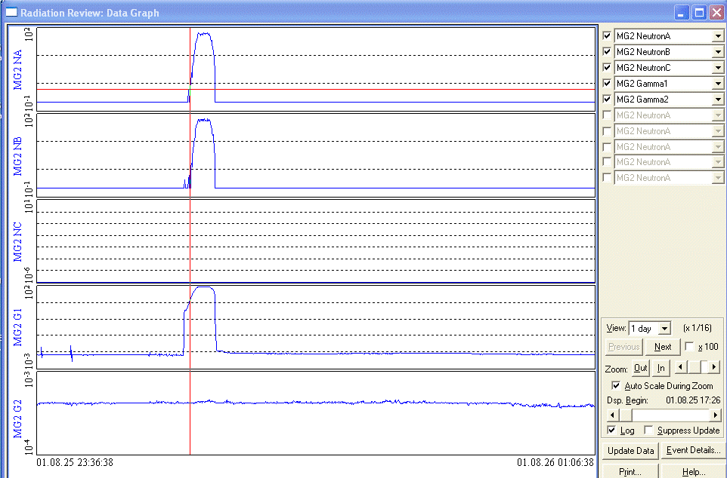
Figure 11 Examining a Radiation Peak on the Graph

With a good heuristic value for threshold detection at hand, start the ‘Find Channel Events’ operation by selecting the ‘Find Channel Events…’ menu item from the RAD ‘Tools’ menu. (Figure 12)

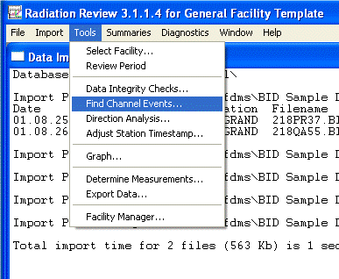
Figure 12 The “Find Channel Events…” Menu Item

The ‘Find Channel Events’ Parameters dialog (Figure 13) is used to specify the station and channels, and the threshold diction limits and technique for automatically detecting events in eh measurement data. In this example, we will scroll down the list of channels available in the RAD database to find the miniGRAND Neutron Channel A.

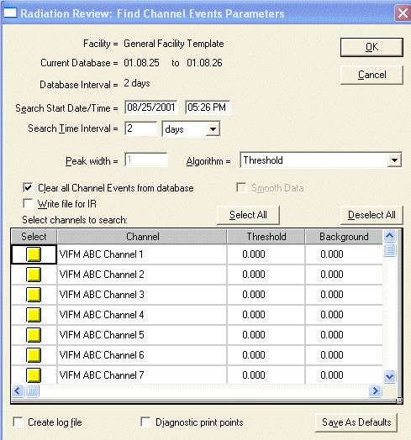
Figure 13 Choosing Channels to Analyze for Events

Here (Figure 14) MG2 NeutronA is selected. No other channels are selected. The detection threshold has been set at 25.00. Select “OK” to start threshold detection.

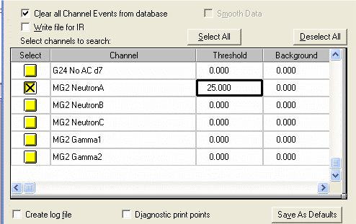
Figure 14 Selecting a Channel and Setting the Peak Threshold Value

The detection processing is displayed in Figure 15. The results show that 22 events were detected, as shown in Figure 16.
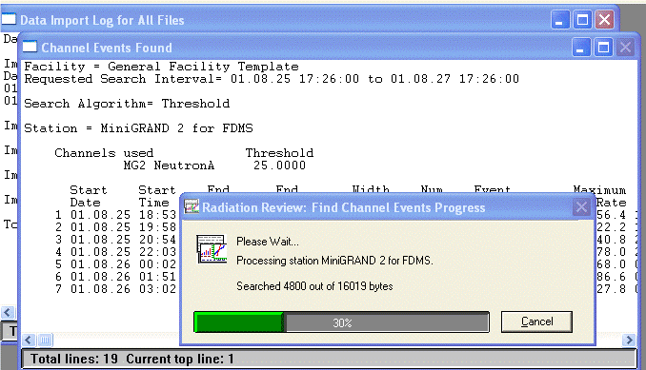
Figure 15 Threshold Detection Progress

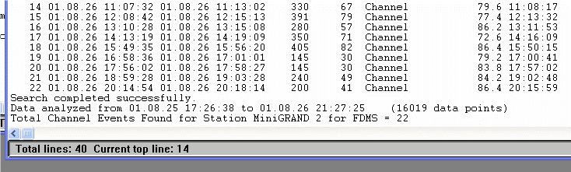
Figure 16 Threshold Detection Results

A review of the graph shows the detected events highlighted in pink in the A channel. It looks good. (Figure 17)
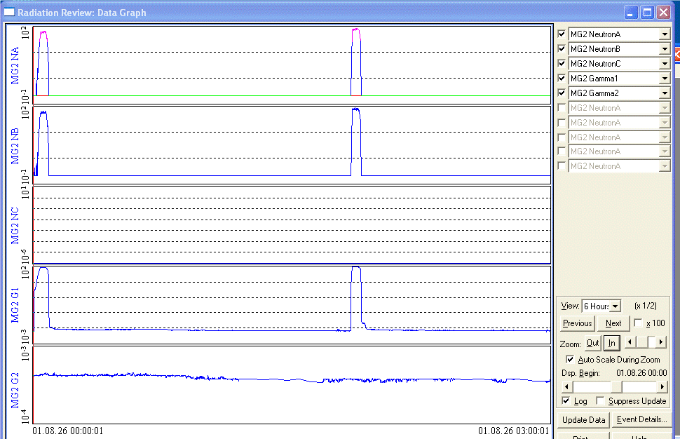
Figure 17 Reviewing the Marked Events in the Graph

Preparing Radiation Review Events for Export to FDMS

The detected events need to be identified with an ID that corresponds to the Assembly ID used by FDMS. In our example, IDs MIC-01 through MIC-22 will be used. Using the Event Details dialog, the event ID can be added. The event area can be modified, and the event type can be specified.

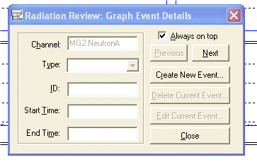
Figure 18 The Graph Event Details Dialog

Figure 19 shows an event selected, with the Event Details dialog ready for editing.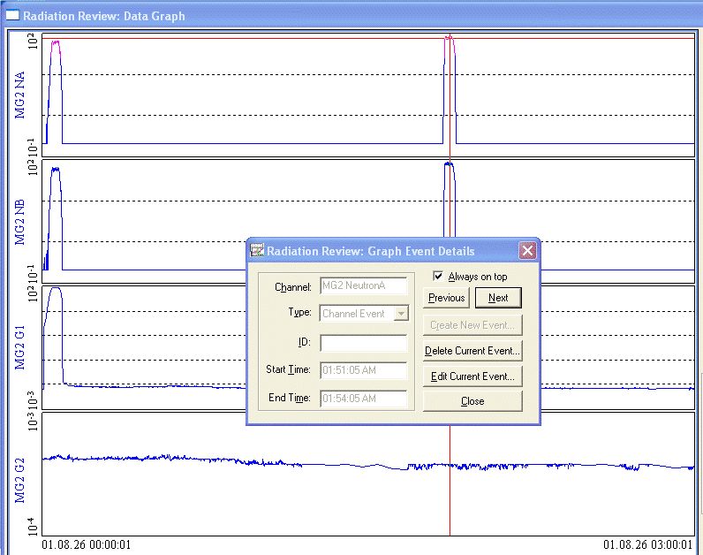
Figure 19 Editing an Event using the Graph Event Details Dialog

Background events.
New in RAD for this release is the creation of background events. FDMS can use a background measurement to adjust the results of a cycle or assembly measurement. The RAD Event Details dialog is used to create an event of type background. Select an arbitrary area of a graph, choose the Background Event type, and save the changes.

Figures 20 through 26 show the creation of a background event prior to the 5th event in the data. The event is created and the area adjusted to correspond only with background. The event is named BKG 5.

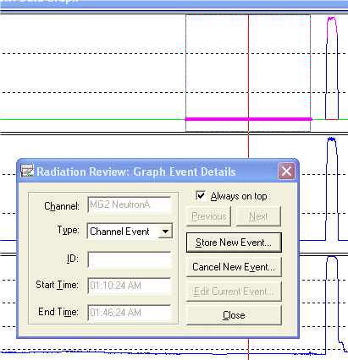
Figure 20 Marking an Area for a New Event.

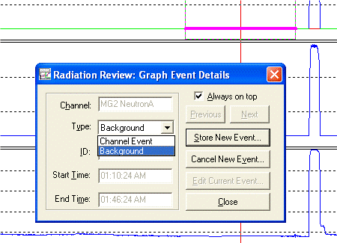
Figure 21 Setting the Background Event Type

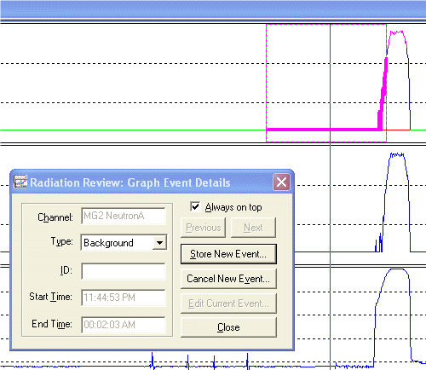
Figure 22 Adjusting the Area Selection

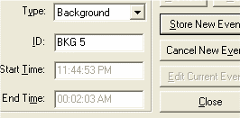
Figure 23 Give the Event the Name “BKG 5”

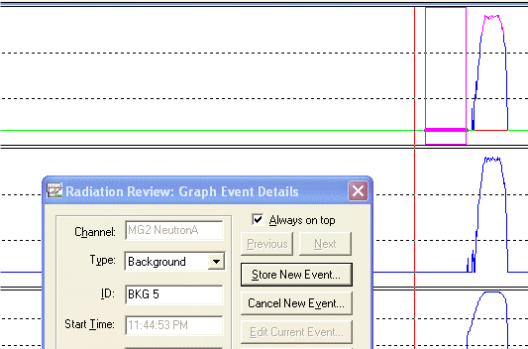
Figure 24 The Background Event “BKG 5” is ready

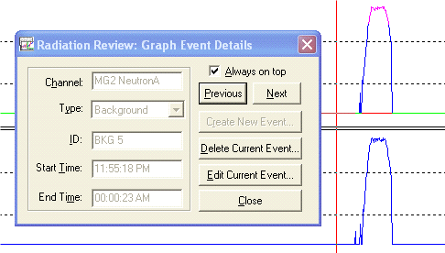
Figure 25 Background Event has been saved

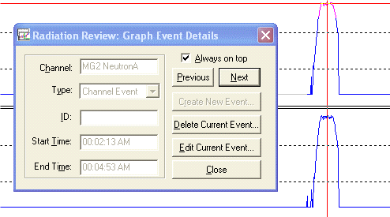
Figure 26 Move to the Next Channel Event

Additional background events can be created as necessary. During the import processing of FDMS, multiple background measurements can be used. When a measurement is analyzed the background measurement corresponding to the closest in time is used in the analysis.
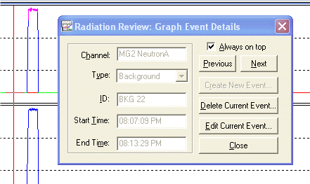
Figure 27 Another Background Event

Exporting Radiation Review Measurement Events to FDMS

After events have been identified and edited, they can be exported for use by FDMS. A shared file is created detailing the chosen events. FDMS refers to this file during the import process. To export, open the Export Data dialog from the ‘Tools’ ‘Export Data…’ menu item.

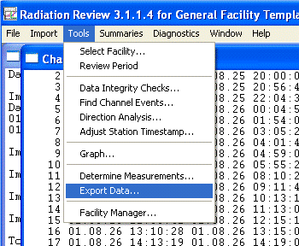
Figure 28 The “Tools” “Export Data…” Menu Item

In the “Export Data” dialog, you select the types of measurements to export, and the stations or detectors that are the source of eh events. FDMS uses the “Write XML file” export option. INCC uses the “Write NCC files” option, and Integrated Review uses the “Write IR file” option.

For FDMS, (see Figure 30)
- Choose both Static Background and Channel Event to export.
- Make sure that the “Write XML file” option is selected.
- Select the detector that corresponds to the events that were identified in the previous steps.
- Select OK to export.
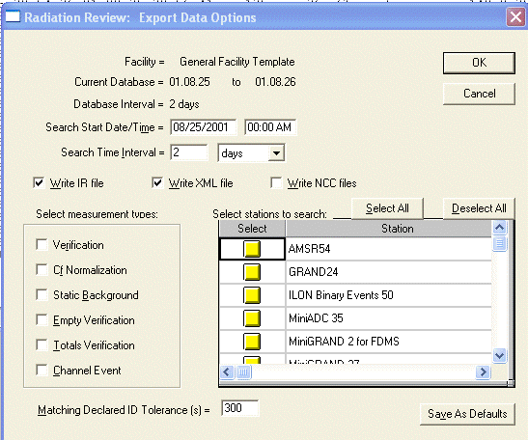

Figure 29 The Export Data Options Dialog

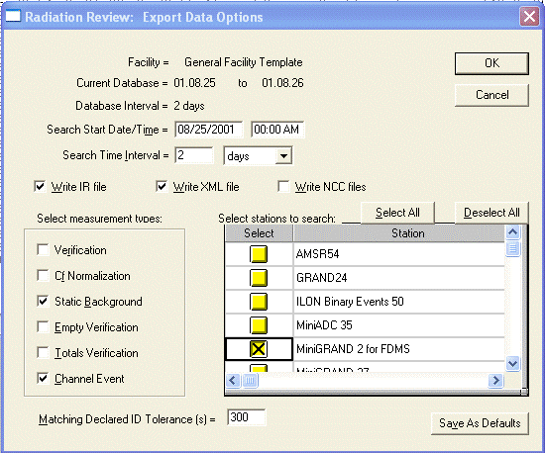
Figure 30 Selecting Background and Channel Events for a Channel

After selecting ‘OK’, a new dialog with a list of all Background and Channel events is presented in an editable tabular format. Here you may enter the unique Assembly IDs corresponding to each measurement event of interest. Select ‘OK’ to cerate the external XML file that is used by FDMS to obtain the specified event data for analysis. Figure 30, Figure 31, and Figure 32 show the editing process. Figure 33 show the progress indicator during the export processing.
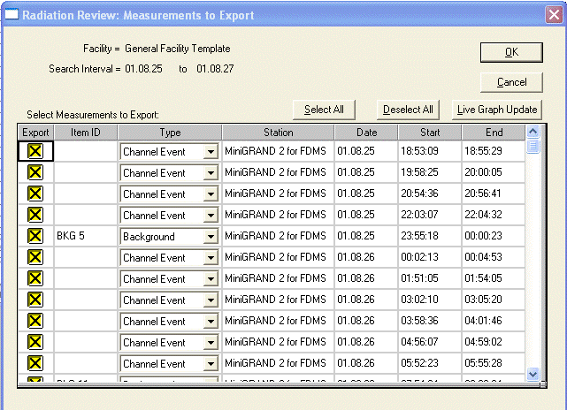
Figure 31 The Table of Events to Export

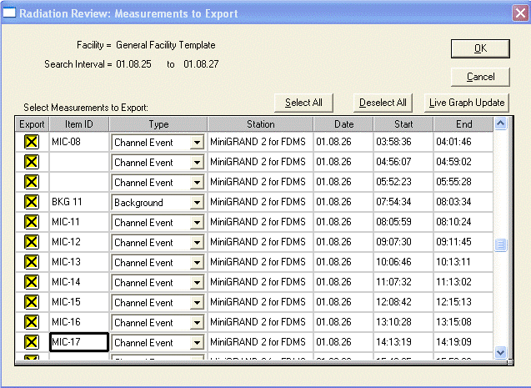
Figure 32 Editing Individual Events

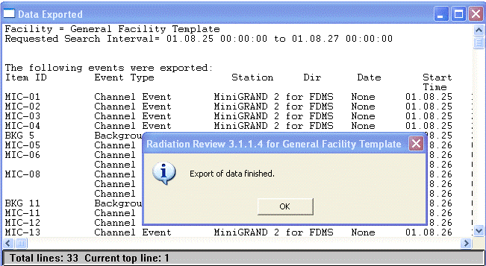
Figure 33 Data Export Results

A log similar to this example is made during the export processing.

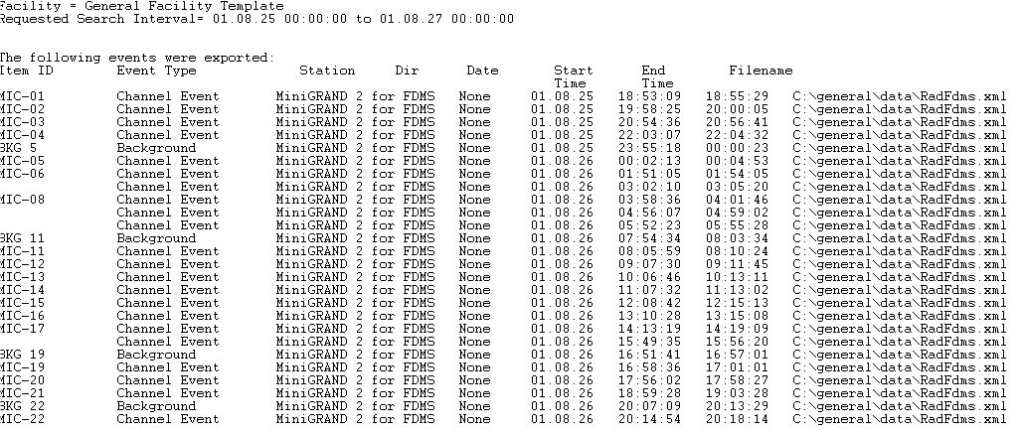
Figure 34 Data Export Summary Log

FDMS Analysis; Importing Events from Radiation Review

Unattended measurement data has been prepared for analysis in FDMS using RAD. Start FDMS from the same menu used to start RAD (see Figure 1). FDMS looks similar to Figure 35 when started.

The FDMS integration has added the toolbar seen below the menu, and the “Tools” menu. The toolbar controls and the “Tools” menu items fulfill the same function. All integrated tools can be started from the “Tools” menu (Figure 36), or from the drop down list on the tool bar (Figure 37). If exported data is available to be imported into FDMS, a menu item ‘Import Measurements …’ is present and enabled on the “Tools” menu (Figure 36). Similarly, the last button the tool bar will enabled if exported data is available (Figure 38 Figure 39). The toolbar button is a convenient for starting the FMDS data import processing. Selecting ‘Import Measurements …’ or pressing the toolbar button starts the FDMS import processing.

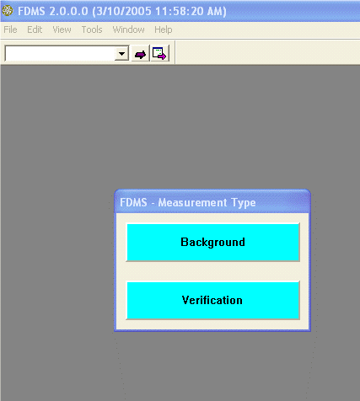
Figure 35 FDMS
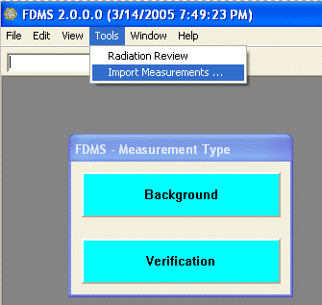
Figure 36 The FDMS “Tools” Menu Item
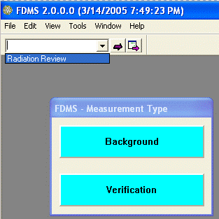
Figure 37 The FDMS Toolbar IRS Tools Pulldown Menu
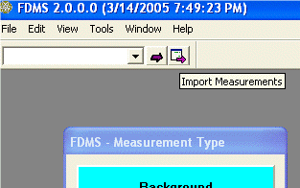
Figure 38 The FDMS Toolbar "Import Measurements” Button

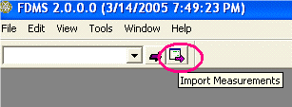
Figure 39 The FDMS Toolbar “Import Measurements” Button

The FDMS import process uses three sequenced steps to import, analyze and retain events in FDMS.
- Background measurements presented in a table dialog. Each event is represented by arrow. Columns represent the various relevant data fields for a background measurement. The background measurements are processed and retained by user actions with the table dialog. Then …
- New measurements are presented in a table dialog. A new measurement, one not found in the FDMS database, must be completely specified, successfully analyzed and then accepted, before it is saved by FDMS. The user edits the relevant data fields, affirmatively analyzes selected events, and finally accepts one or more successfully analyzed events. Visual indicators are used to flag missing data. Then …
- Existing measurements that will be updated are presented in a third dialog. These events are selected, analyzed and finally accepted into FDMS in the same manner as Background and New measurements. The same visual indicators used in New Measurements analysis are used in the Existing Measurements table dialog.

Background events require little intervention; they are simply selected and analyzed. New events and events that are replacing existing measurements in FDMS require the completion of up to seven data items before a successful analysis can occur.

FDMS Import Measurement Dialog Details

When the import processing is complete, the FDMS graphs can be used to evaluate the imported measurements for safeguards analysis.

Several affirmative user actions are required to analyze an imported event.
- A check box is provided with each event row. The check box must be selected in order to analyze an event. Deselecting an event checkbox will cause FDMS to skip the analysis of the event.
- Selected events are analyzed by pressing the “Analyze Selected Events” button
- The ‘Accept Measurements’ button is selected to retain the analyzed events in the FDMS database. Only those events that are selected and have been successfully analyzed will be saved using the ‘Accept Measurements’ button.
- The ‘Close’ button will close the Background, New and Existing Measurements dialogs, and no events form that table dialog will be saved in FDMS.

Visual Status Indicators
To support identification of required data values, and to display the status of ongoing event analysis, color text highlights, and table row and cell background colors are used in the table dialogs as indicators.

Informational data | Immutable fixed data values, those values that cannot be changed, are displayed in basic black text with white background.
Required data | Data values that must be changed or initially specified by the user before a successful analysis can occur are displayed with a blue background.
Required data not specified, or out of range | Required data items are highlighted with magenta text after an analysis is performed on an event row with incomplete required data fields.
Successful analysis | A successfully analyzed event has the entire row displayed with a soft green background. The ID of the event is displayed with bold text.

Editable Event Fields
Each new or existing event is edited by the user until it is complete enough to analyze. To complete an event for analysis, these data fields must be completed:
- ID
- Measurement Type; Cycle Verification or Assembly Verification
- Enrichment %
- Burnup (GWd/MT)
- Discharge Date; defaults to January 1, 1950. Cooling time is computed from this date.
- Cycle #; 1, 2, 3, …
- Cooling time (in years). If a cooling time is specified the Discharge Date is computed based on the Measurement Date.
- Optional: the Facility Name and Detector may be changed.

ID An event imported from RAD may have an ID, or it may not. The ID may be entered or modified in the tabular import dialogs for Background, New and Existing Measurements.

Measurement Type
For channel events, the user must specify that the event is a Cycle Verification or Assembly Verification measurement. The initial value for each new event is ‘Unspecified’. Existing events use the type specified for the pre-existing measurement in the FDMS database.

Enrichment % and Burnup (GWd/MT)
Both must be specified for Assembly Verification measurements. These may be left at 0 for Cycle Verification measurements.

Discharge Date
Defaulting to January 1, 1950, this value must be edited by the user before an analysis of the event can occur. A cooling time or a discharge date must be specified for each new and existing measurement. Entering a discharge date will automatically fill out the cooling time field. The cooling time is computed from the time span of the discharge date up to the measurement date. The measurement date is defined by imported event data, and cannot be changed.

Cycle #
The fuel cycle # is specified using a combo box list. The number is set at 1 when the import processing starts. Modify this number as needed.

Cooling time (in years)
Defaulting to the time from January 1, 1950 to the present, this value must be edited by the user before an analysis of the event can occur. A cooling time or a discharge date must be specified for each new and existing measurement. Entering a cooling time will automatically fill out the discharge date field. The discharge date is computed from the time span of measurement date, less the cooling time.

Background measurements

The New Background Measurements dialog is shown in Figure 40. Notice the check boxes sin the first column. To analyze a background measurement, the check box must be selected. The “Analyze Selected Entries” button is pressed to perform the analysis. The results of the analysis appear as the computed values for Neutron channels, A, B and C, and Gamma 1 and 2. In Figure 40 here, all four background events have been selected or analysis.

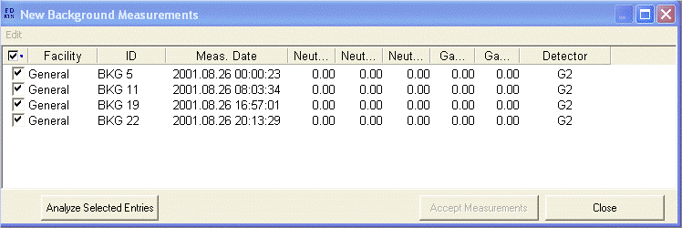
Figure 40 the FDMS Import Background Measurements Dialog

Figure 41 show the result of pressing the “Analyze Selected Entries” button. Each of the four background measurements has been computed, the numerical results are displayed in the channel columns. The alternating soft green background is the visual indicator of a successful event analysis.

Selecting “Accept Measurements” will retain the any selected and analyzed background measurements in FDMS, to be used in the next import processing steps.

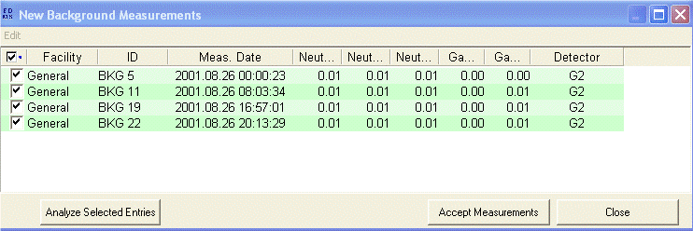
Figure 41 The Background Dialog with Four Successfully Analyzed Background Measurements

Importing New Measurement Events

After Background event processing, the “New Measurement Events’ table is displayed. Here is each channel event exported from RAD, one event per row. The cells or fields with a blue background represent data that can be edited by the user, or that must be specified by the user. Note that the Measurement Date column is not editable. The measurement times and dates come from the original event data and cannot be changed.

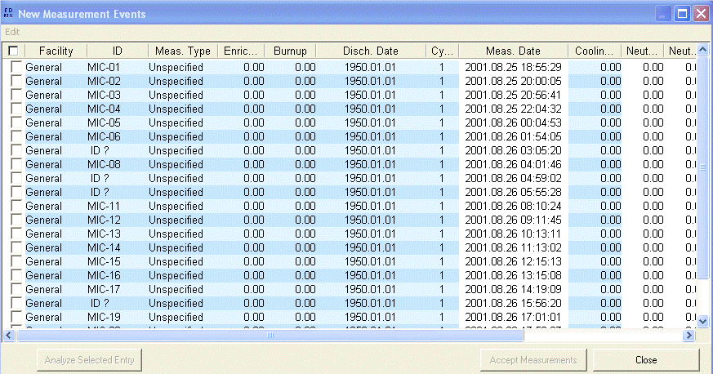
Figure 42 The FDMS Import New Measurements Dialog

Let’s get started with the data editing. Figure 43 shows a cycle # being selected using the cycle # combo box in the cell. The value is about to be changed to 3 for the selected events. Notice that three events have been selected for analysis, using the checkbox in column one.
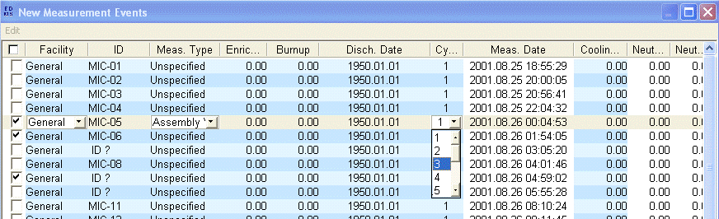
Figure 43 The New Measurements Dialog with a Cycle # Selection in Progress

Figure 45 shows the visual indicators for of incomplete data. The “Analyze Selected Entries” button was pressed in Figure 44, but no analyses were successful, all due to incompletely specified information.
- ID MIC-O5 is an Assembly Verification measurement. Both Enrichment and Burnup are required for that measurement type t be successfully analyzed.
- ID MIC-O6 does not have a measurement type specified, nor has the initial default value for the Discharge Date been changed.
- ID “?” does not have an ID specified. Plus, like MIC-06, it is missing measurement type and discharge date.

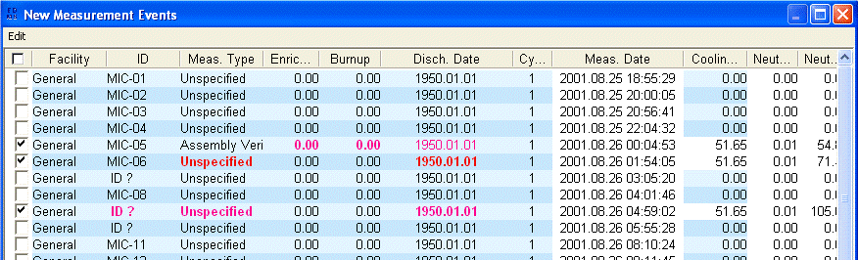
Figure 44 The New Measurements Dialog with Required Event Data Highlights

Figure 45 shows how a cooling time can be entered; the discharge date will be modified accordingly.
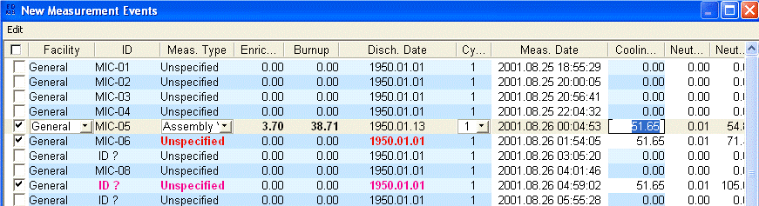
Figure 45 The New Measurements Dialog with Cooling Time Editing

Figure 46 shows the successful result of an analysis after the missing cooling time/discharge date has been entered. The entire row is now green. The ID is displayed in bold text. This measurement can now be accepted into FDMS. Note that the cycle number is red. This is a secondary indicator that the number was not changed, but may be desirable to change.

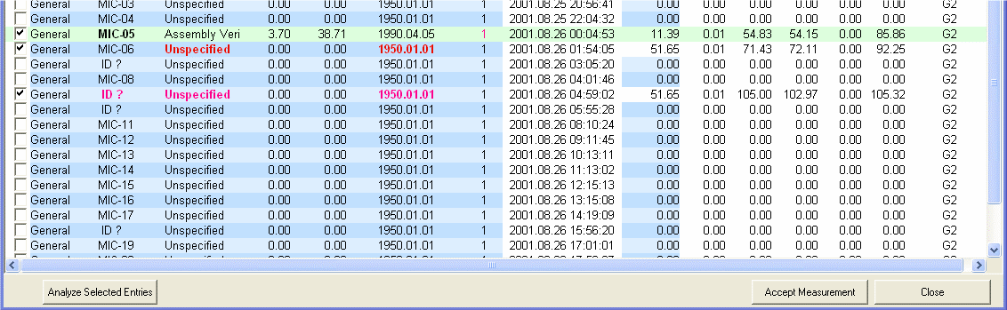
Figure 46 The New Measurements Dialog with a Successful Assembly Verification Analysis

Figure 47 shows the editing of the missing ID. The other required values have already been updated, and the changed values are still highlighted after editing, as seen in Figure 48. The analysis of the MIC-06 and MIC-09 events will now succeed, because all of the required data has been entered. Pressing the “Analyze Selected Entries” button again result in three successful measurements, ready to be accepted into FDMS (Figure 49).

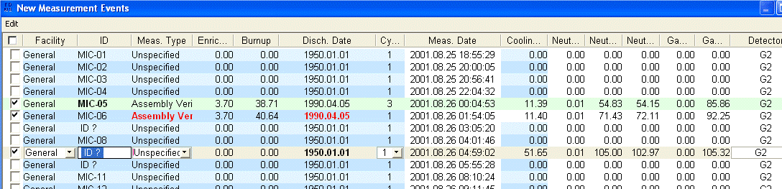
Figure 47 The New Measurements Dialog with ID Editing

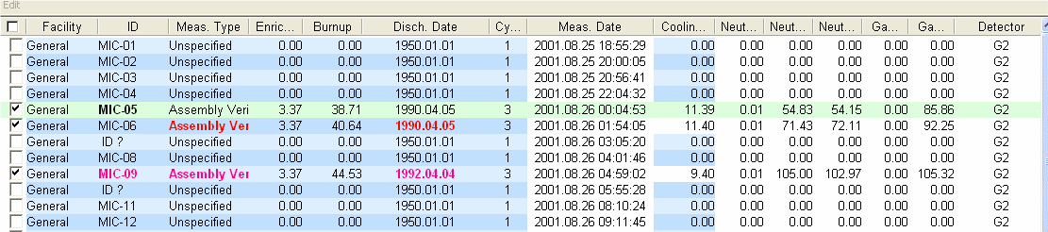
Figure 48 The New Measurements Dialog with ID Editing Completed

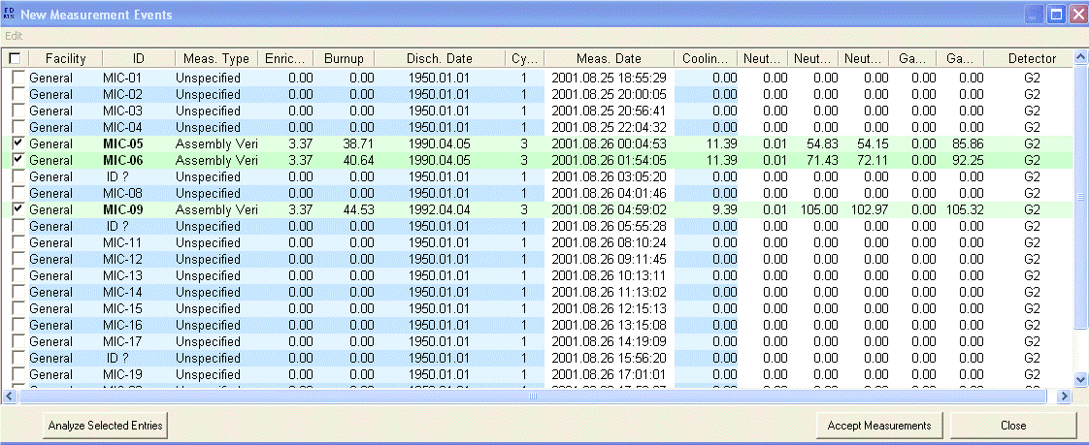
Figure 49 The New Measurements Dialog Showing Three Successful Assembly Verification Analyses

Here, the “Accept Measurements” button can be pressed, and the 3 valid measurements will be retained in FDMS. The next step is to review the newly imported and analyzed measurements using the existing FDMS graphs.

Reviewing the Import Analysis Results

Activate the Assembly Verification graphs to see the placement of the three newly analyzed events.

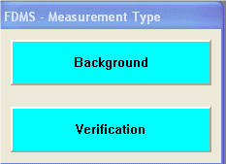  Figure 50 FDMS First Menu | 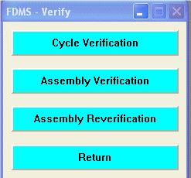  Figure 51 The Verification Menu | 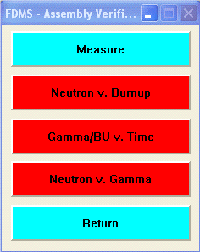  Figure 52 The Assembly Menu

The Neutron v. Burnup graph shows the three measurements fitting nicely in a range.

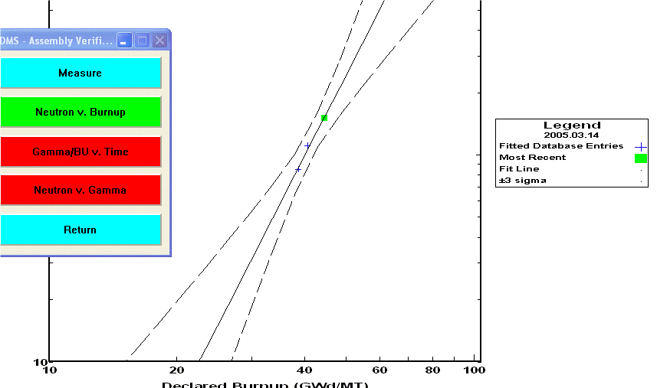
Figure 53 The FDMS Neutron v. Burnup Graph

Activate the FDMS measurement plan table to review, edit and measure the measurements again.

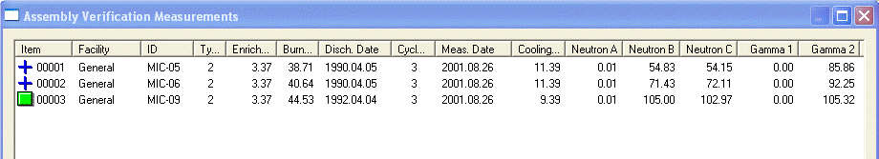
Figure 54 The FDMS Assembly Measurements Dialog

Importing Existing Measurement Events

Previous FDMS measurements may be analyzed, using new data and measurement times, when importing events from Radiation Review. An imported event with an ID that matches an existing Assembly ID in the FDMS measurement plan will be presented in the Existing Measurements dialog.

Each existing measurement, and the new event that will replace the existing measurement, are shown in pairs in the dialog. The existing measurement is shown as a disabled row without a check box, above the measurement event that will replace it. Similarly to the New Measurements dialog, the fields with the blue background may be modified for the analysis.

When the event details have been edited appropriately, select those measurements to be analyzed by checking the associated check box in the first column. Review the numerical results, and make any changes needed to produce a satisfactory analysis result.

To save the measurement data, select the ‘Accept Measurements’ button. For each measurement that is to be replaced, FDMS requires an approval step. The new and existing values for each measurement are shown, select ‘Accept’ to replace the measurement data, select ‘Reject’ to skip to the next measurement.

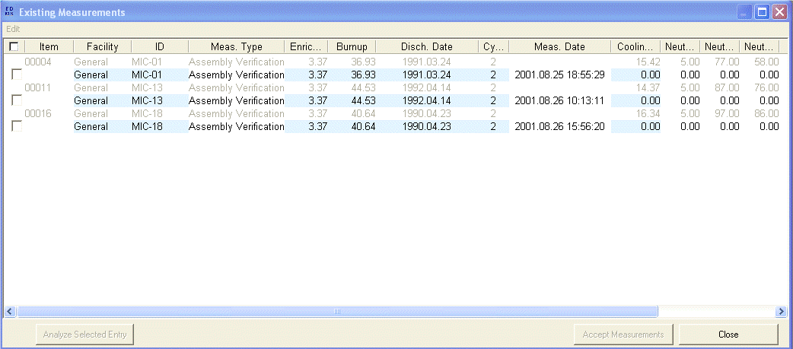
Figure 55 The FDMS Import Existing Measurements Dialog

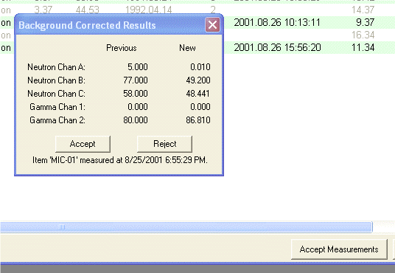
Figure 56 Accepting Analysis Results for an Existing Measurement

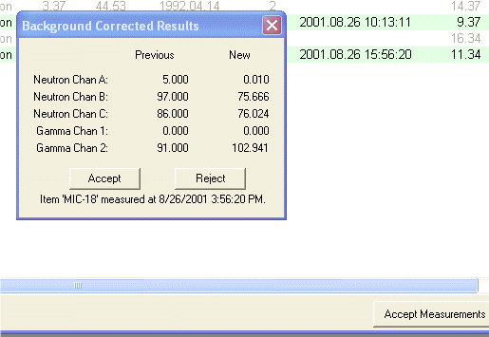
Figure 57 Accepting Analysis Results for an Existing Measurement

Moving Data from Excel to FDMS

The current FDMS table dialogs have limited editing capability. Microsoft Excel is the standard by which all other tabular editable dialogs are measured, and so some support for pasting columns of data from Excel has been provided. By using the proper column titles, FDMS can match an attempt to paste a column of data into the New or Existing Measurement table dialogs.

Each FDMS database file is a comma-separated text file with a header row. The three files that comprise the FDMS database all use the same header row titles internally. By creating columns of data with a matching header cell title, FDMS can identify the column to paste data from Excel.

The procedure:
Copy the database or measurement plan file that is installed with FDMS. Open this copy in Excel; delete all data rows, leaving the header row intact. Use Excel to enter data in the column required. The fields that can be pasted from Excel into FDMS are Facility, Detector, ID, Measurement Type, Cycle #, Enrichment, Burnup and Cooling Time. These are the data fields that are required editing when importing events into FDMS.

Shown below is an Excel spreadsheet with columns of data for ID, cycle #, Enrichment, Burnup and Cooling Time. The series of figures following show the copy and paste operations from Excel to FDMS. First, as selection of a column of data in the Excel spread sheet is shown, an implicit copy command (Ctrl-A) is performed, but not shown. The selected column data is copied to the Windows clipboard. Next, activate the FDMS import processing dialog, click anywhere on the dialog rows, and then use the dialog ‘Edit’ ‘Paste’ menu item to paste the data into the appropriate column. In the example, cycle #’s are copied into the cycle # column.

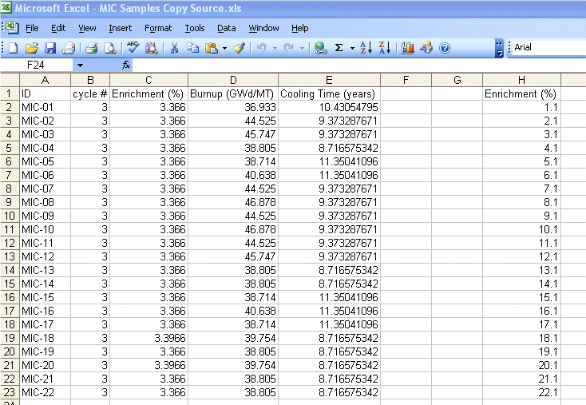
Figure 58 Sample Excel Spreadsheet with FDMS Columnar Data

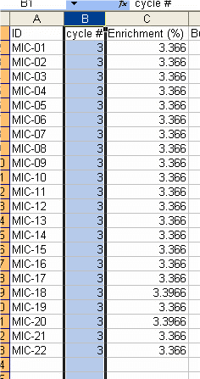  Figure 59 Selecting the “cycle #” column | 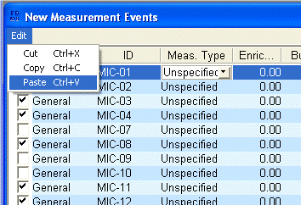  Figure 60 The Paste Menu Item on the FDMS Import New Measurements Dialog | 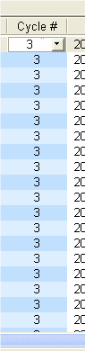  Figure 61 Results in FDMS of pasting the “cycle #” columnar data

Copying from Excel, pasting into FDMS, and the Results.

After a series of copy/paste operations, the fields for ID, Cycle #, Enrichment, Burnup, Cooling Time (and this Discharge Date) have all been specified. The content was copied from columnar data in an Excel spreadsheet. Now, the analyses of these events can proceed.

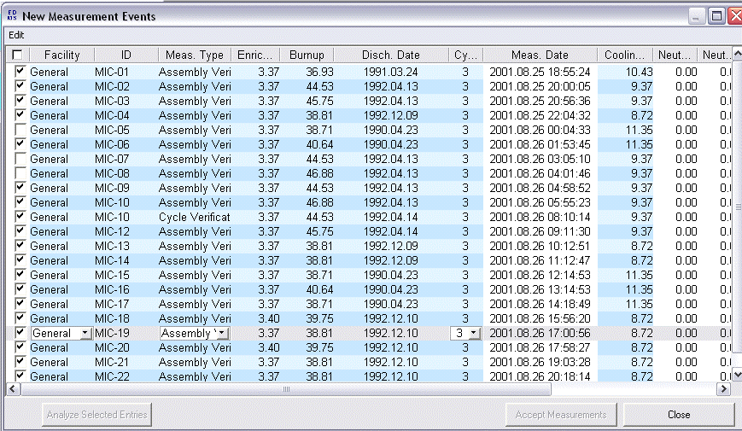
Figure 62 New Measurement Dialog Data Fully Populated using Excel as a Copy/Paste Data Source

All of the selected measurements in this example have been successfully analyzed. When the “Accept Measurements” button is pressed, each such measurement will be saved into FDMS.

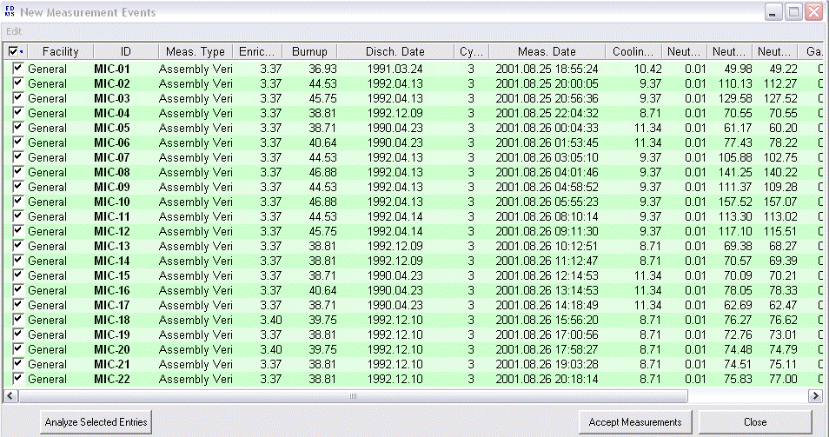
Figure 63 New Measurement Dialog Data with Completed Event Analyses

Reviewing the results
Again, the imported measurements analysis results can be reviewed in FDMS. Below are screen shots of the MIC-## sample data as analyzed by FDMS.
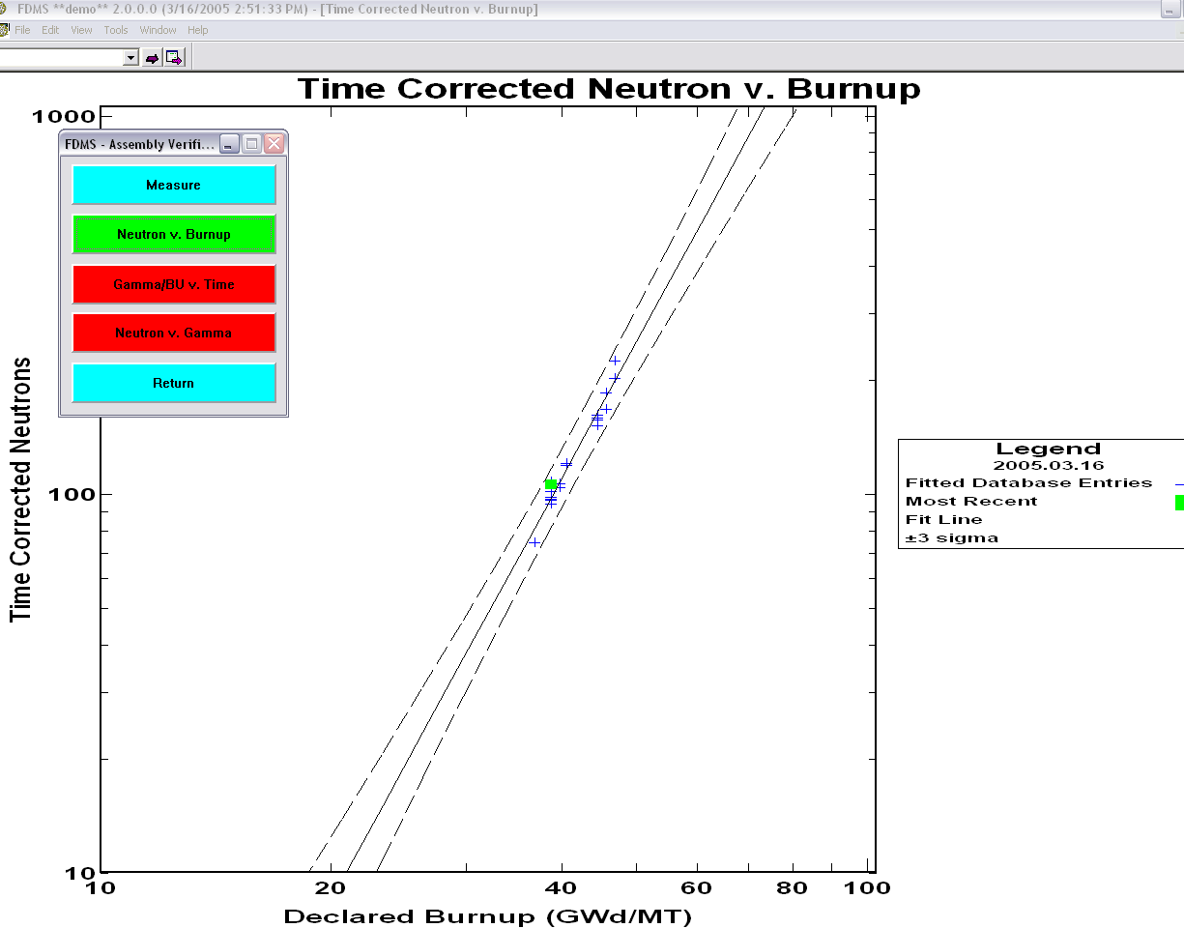
Figure 64 Viewing the Imported Measurements in an FDMS Graph

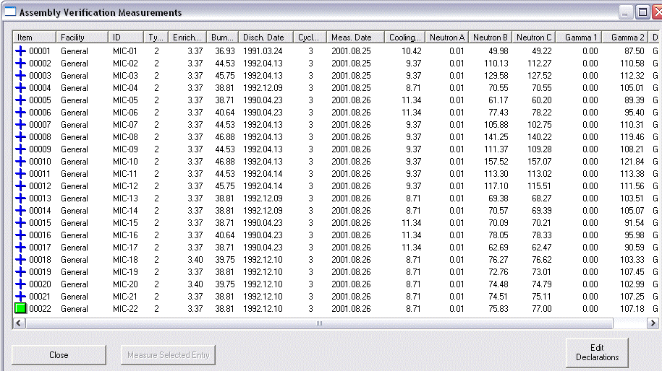
Figure 65 The Same Events in the Assembly Verification Measurement Dialog

Preparing a Facility using the Facility Manager

FDMS and Radiation Review work together through the IRS Facility Manager. This section shows how to set up a new station in an existing facility definition. The Facility Manager is started from the Radiation Review Tools menu, or from the Integrated Review Software “Start Facility Manager” menu item on the Windows Start menu.

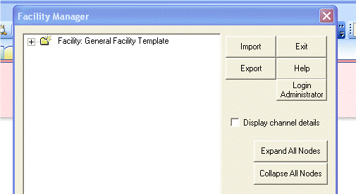
Figure 66 Opening View of the Facility Manager

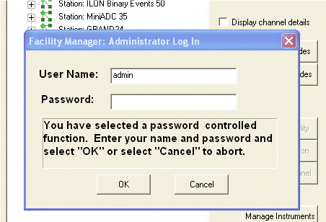
Figure 67 Obtaining Edit Permissions

Detector or Station Definition
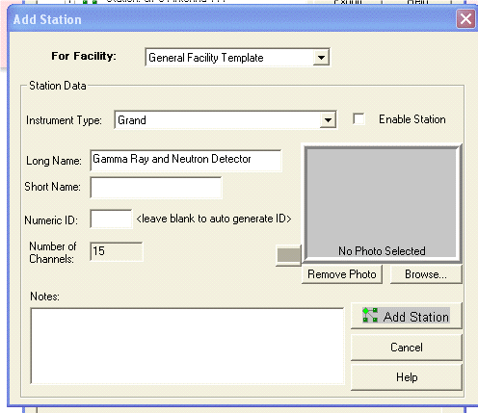
Figure 68 Add a New GRAND Station

Naming: Long, Short, Numeric ID

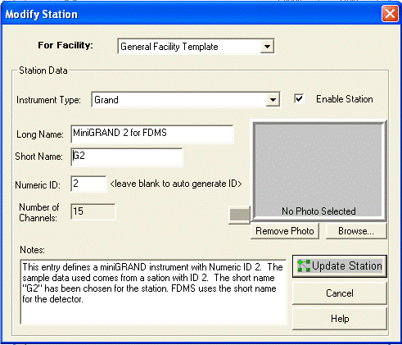
Figure 69 The New Station, Fully Specified.

Channels
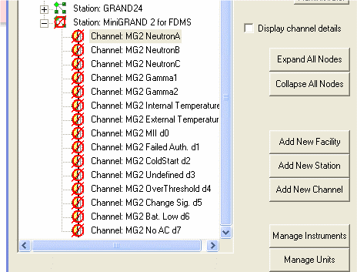
Figure 70 The Station Channels
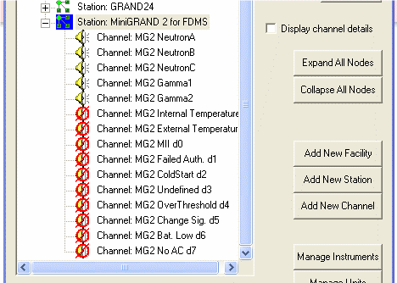
Figure 71 Enabling the Channels of Interest

\

Copyright Notice and Disclaimer
This work was supported by the United States Member State Support Program to IAEA Safeguards; the U.S. Department of Energy, Office of Nonproliferation and National Security, International Safeguards Division and the U.S. Department of Energy, Office of Safeguards and Security. POTAS Task number A252.14
Copyright 2005, The Regents Of the University of California. This software was produced by the Safeguards Science and Technology Group (N-1).
This software and accompanying documentation was produced under a U.S. Government contract (W-7405-ENG-36) by Los Alamos National Laboratory, which is operated by the University of California for the U.S. Department of Energy. The U.S. Government is licensed to use, reproduce, and distribute this software.
Neither the Government nor the University makes any warranty, express or implied, or assumes any liability or responsibility for the use of this software.

